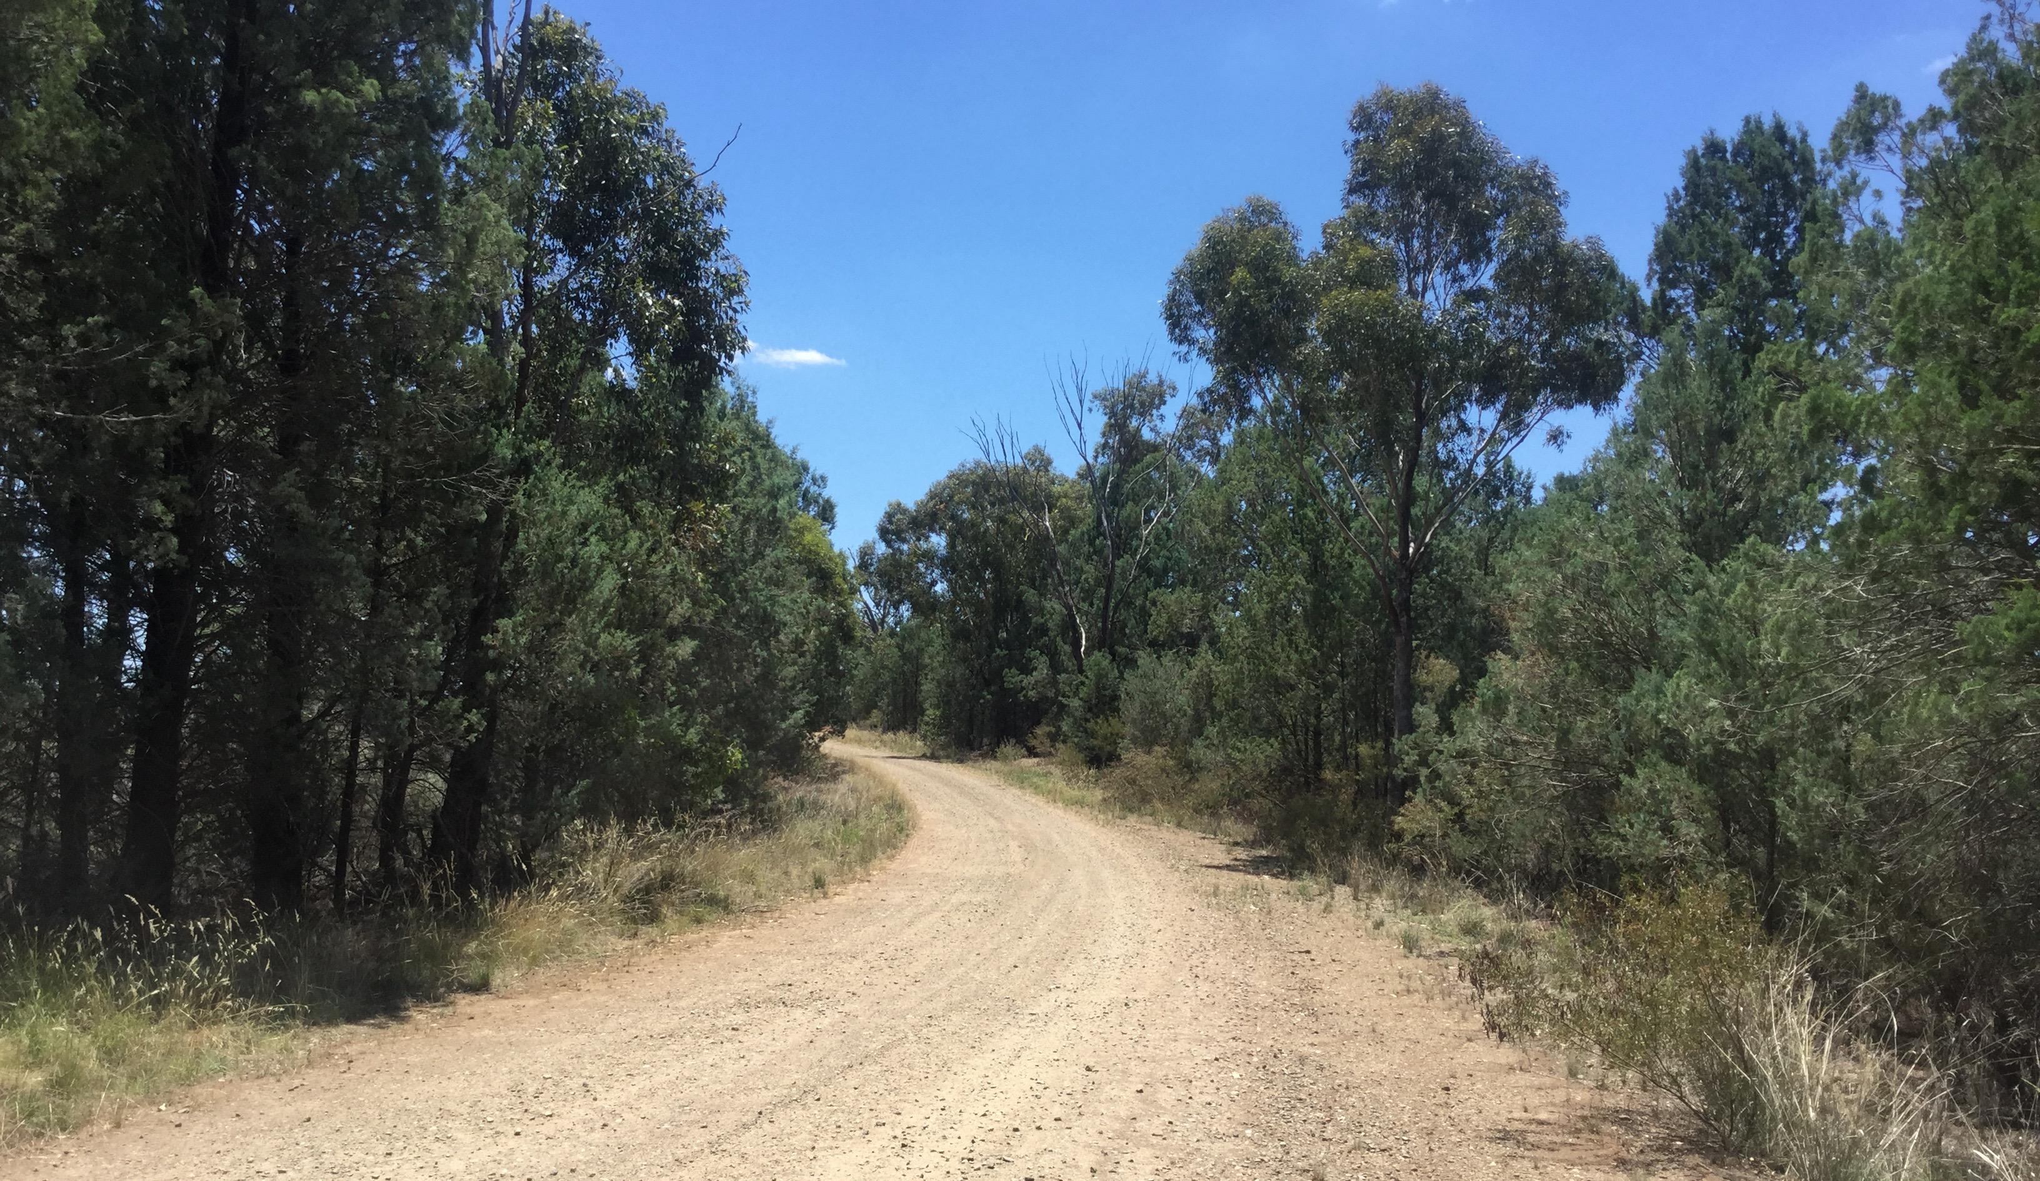

Council Roadside Reserves Project

Guidelines for Updating Strategic Asset Management Plans to Include Natural Assets

Integrating Natural Asset Management into
Council Asset Management Systems

Acknowledgements
This document has been prepared by Cardno (NSW/ACT) Pty Ltd for Local Government NSW (LGNSW) as part of the NSW Environmental Trust funded Council Roadside Reserves Project.
November 2019
Cover: Roadside Vegetation in Wagga Wagga LGA (Photo: CT Environmental)

This project has been assisted by the New South Wales Government through its Environmental Trust.

Contents
1. Introduction 1
2. Guidelines 2
2.1. Asset Management Policy 2
2.2. Asset Management Objectives 2
2.3. Language and Terminology 2
2.4. Asset Portfolio Overview 2
2.5. Asset Criticality and Risk 2
2.6. Data Hierarchy 2
2.7. Asset Management Plan Summaries 3
2.8. Governance Framework 3
2.9. Key Stakeholders 3
2.10. Whole of Life Asset Management 3

List of Tables
Table 1 Natural Assets Data Hierarchy 2

Introduction
This document provides basic guidelines for updating existing council Strategic Asset Management Plans (SAMPs) to include natural assets. The guidelines have been derived from SAMP examples provided by Muswellbrook Shire Council and Port Stephens Council.
The development of these guidelines is part of the Local Government NSW Council Roadside Reserves project, specifically Integrating Natural Asset Management into council Asset Management Systems.
In the context of the Local Government NSW Council Roadside Reserves project natural assets are confined to linear assets on roadside reserves. However, these guidelines are sufficiently broad to apply to other natural assets, outside of roadside reserves.
These guidelines are generic, they do not assume a specific structure or content of a SAMP.

Guidelines

Asset Management Policy
Consider the scope of the Asset Management Policy. Where it is not asset class specific and can be applied to any council asset class no change is required. A policy that lists specific asset classes will require amendment to list or nominate natural assets. When adding the natural assets adhere to the hierarchy of data established in the policy (for example use the name of the asset class, asset type, or asset component as applicable).

Asset Management Objectives
Asset management objectives are often asset class specific. Assess the existing objectives and derive additional objectives to incorporate natural assets as necessary. Ensure the new objectives align with corporate strategy and direction.

Language and Terminology
Language and terminology throughout the SAMP needs to reflect the set of asset classes covered by the SAMP. Replace any specific reference to a type of asset, such as ‘infrastructure’ with ‘asset’ where applicable.

Asset Portfolio Overview
Many SAMPs provide a high level summary of asset classes. Add into the graphic, table or list the same summary information for the natural asset class. This will often be some basic quantitative information, a summary of condition and a summed replacement cost.
Where condition is summarised in the SAMP ensure the condition rating used is the same, or aligned to the other asset classes. This may require manipulation of the natural asset condition data to align with the condition rating used for other assets. In cases where this alignment is not possible a separate condition summary may be required for the natural asset class.

Asset Criticality and Risk
Identify any natural assets that are deemed critical (using councils definition for ‘critical’) and assess risk (using councils shared or corporate risk framework) associated with these assets. Add this risk to the risk summary in the SAMP, including a risk management strategy.

Data Hierarchy
Derive and summarise a data hierarchy for natural assets to add to the SAMP. The data hierarchy developed through the Local Government NSW Council Roadside Reserves project is provided below (Table 1) for consideration:
Table 1: Natural Assets Data Hierarchy
Asset Class | Asset Type | Asset Component | Asset Subcomponent
Natural Assets | Bushland | Roadside reserves  Riparian reserves | Trees  Shrubs  Grasses
 | Trees | Street trees  Roadside trees  Forest trees
 | Water ways | Creek  River  Ocean  Estuary  Lake  Wetland  Pond | Riparian edge  Weir  Bed  Water  Bank  Aquatic vegetation
Ensure similar asset types or components are distinguished from other asset classes, such as parks, reserves, open spaces and drainage.

Asset Management Plan Summaries
Where the SAMP incorporates Asset Management Plan summaries, use the same summary structure as used for the existing SAMP asset classes for the natural assets and append to the SAMP.

Governance Framework
Ensure asset management governance incorporates that for natural assets. This may require resources outside of the infrastructure asset management team to be identified, such as Environmental Managers. Consider adding in an organisational chart to provide clarity, or adding in relevant resources to the existing chart.

Key Stakeholders
Review the list of key stakeholders in light of the full scope of asset classes covered by the SAMP. Add any stakeholders that are not listed but key to natural assets. These may be internal or external stakeholders.

Whole of Life Asset Management
The asset management lifecycle can be applied to all asset classes but there may be variations to the activities in each lifecycle step for natural assets. Ensure the lifecycle described in the SAMP can be applied to natural assets and amend where necessary. Consider the following description of the life cycle for roadside reserve natural assets:
- Planning. This involves the identification of need, options analysis and justification of the proposal. This process can include seeking advice from professionals on proposals, etc. Careful planning of new or upgrading of road infrastructure, can be key to achieving good outcomes for roadside vegetation assets (eg by routing new roads to avoid ecologically sensitive areas), maximising new bushland asset size and connectivity and managing water runoff so bushland hydrology does not change, are central to protecting integrity and reducing costs of maintenance in the longer term.
- Acquisition. This is the purchase and planting of the roadside vegetation based on the decisions made in the planning phase
- Operate and Maintain. The maintenance strategy is to maintain the roadside vegetation to a relevant standard to meet the Level of Service. This includes regular inspections, maintenance and reporting. Inspections are to be undertaken to understand where the roadside vegetation assets are within their lifecycle and their condition, to enable adjustment of maintenance regimes where necessary.
- Renewal. Asset condition generally deteriorates over a long period of time, depending on asset demand, and require renewal. Renewal often forms a large component of the budget and correct information at this stage of the process is paramount to making cost effective decisions that will deliver the required levels of service. Roadside vegetation assets are considered to have long useful lives thus asset renewal is generally lower frequency, if at all (for those that do not deteriorate). It is typically more cost effective to maintain in good condition (ie regular but not necessarily expensive weed control) than to replace an area of roadside vegetation.
- Rationalisation and Disposal. Roadside vegetation has a long asset life if maintained adequately and demands are managed. However, elements of roadside vegetation also interact with other assets in the road reserve and may pose safety threats to road users. Disposal of roadside vegetation may be required if it sits within the road clear zone or tree roots are causing pavement deterioration or infiltrating underground services.

